CHEM 2324 Exam 4 Name:

July 10, 2023 UTEP ID #:

If required, the exam retake homework will be due ***tomorrow***, Tuesday, July 11, before 5 pm through <http://organic.utep.edu/quiz>, no exceptions or excuses. Expect an email from me this evening.

1. How many *R* chiral centers are in the following antiviral drug? A structure of a chemical formula

   Description automatically generated

a. 1 b. 2 c. 3 d. 4 e. not a.-d.

1. Is the following Newman projection? 

a. achiral but not meso b. chiral c. meso d. not a.-c.

1. What is the relation between the structure in question 2 and the following structure? 

a. constitutional isomers b. diastereomers c. enantiomers d. equivalents e. not a.-d.

1. The following compound for sure is? 

a. *L* b. *l* c. *D* d. *d* e. not a.-d.

1. What is the major composition of a mixture of enantiomers that has an observed rotation of 80°, where the pure enantiomers have a rotation of ±100°?

a. 60 % b. 70 % c. 80 % d. 90 % e. not a.-d.

1. The compound in **question 1** has how many diastereomers?

a. 61 b. 62 c. 63 d. 64 e. not a.-d.

1. The following compounds should have the same 13C NMR?

a. true b. false

1. The following compounds should have the same biological activity?

a. true b. false

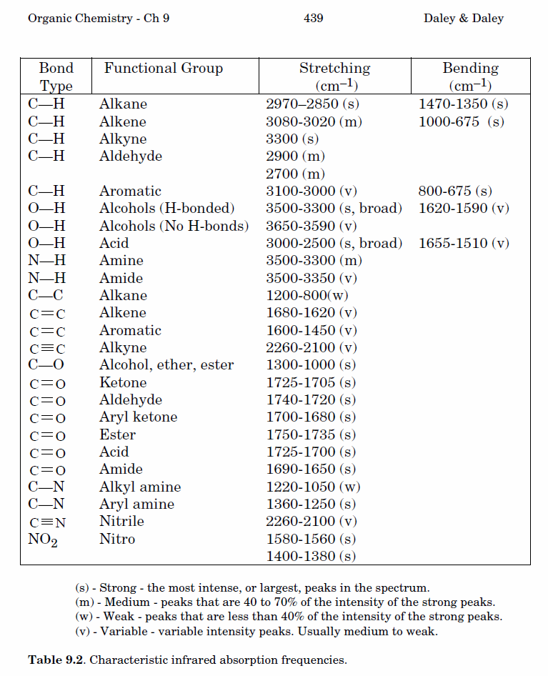9.-12. Classify each pair of numbered hydrogens on *trans*-1,4-dimethylcyclohexane to a topicity relation to the right. Answers may be repeated. For clarity, not all hydrogens are shown.

1. H1 and H2 a. constitutional heterotopic
2. H1 and H3 b. diastereotopic
3. H3 and H5 c. enantiotopic
4. H4 and H5 d. equivalent (homotopic) e. not a.-d.

13.-17. How many carbon signals do the following compounds have? Answer may be repeated.

1.  14.  15.  16.  17. 

a. 2 b. 3 c. 4 d. 5 e. not a.-d.

18.-22. Exactly match each 1H NMR spectrum to a compound below. Not all multiplicities are labeled.

1.  19.  20.  21.  22. 

a. 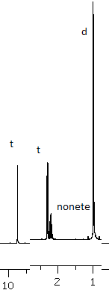 c. 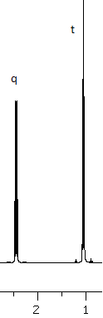 e. 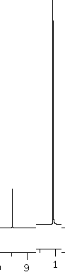

23.-27. Exactly match each IR spectral listings to a compound to the right. An IR table is on the back of the first sheet.

23.  24.  25.  26.  27. 

