CHEM 2324 Exam 4 Name:

July 8, 2019 UTEP ID #:

If required, the exam retake homework will be due ***tomorrow***, Tuesday, July 9, before 5 pm through <http://organic.utep.edu/quiz>, no exceptions or excuses. Expect an email from me this evening.

1. How many *R* chiral centers are in the following abortion inducing drug? 

a. 1 b. 2 c. 3 d. 4 e. not a.-d.

1. Is the following Fischer projection? 

a. achiral but not meso b. chiral c. meso d. not a.-c.

1. What is the relation between the structure in question 2 and the following structure? 

a. constitutional isomers b. diastereomers c. enantiomers d. equivalents e. not a.-d.



1. Knowing that in a proper Fischer projection, the carbon chain is draw vertically and the most oxidized carbon is at the top, the following compound for sure is?

a. *L* b. *l* c. *D* d. *d* e. not a.-d.

1. What is the expected optical rotation for a 4:1 mixture of enantiomers, the (-)-enantiomer being the major component, where the pure enantiomers have a rotation of ±100°?

a. -50° b. -60° c. -70° d. -80° e. not a.-d.

1. Popeye was right! How many enantiomer pairs are in the family of stereoisomers of the compound that makes spinach grow muscle? Don’t worry if some of the stereoisomers are not physically possible.



a. 212 b. 211 c. 210 d. 29 e. not a.-d.

1. The following compounds should have the same 13C NMR?

a. true b. false

1. The following compounds should have the same biological activity?

a. true b. false

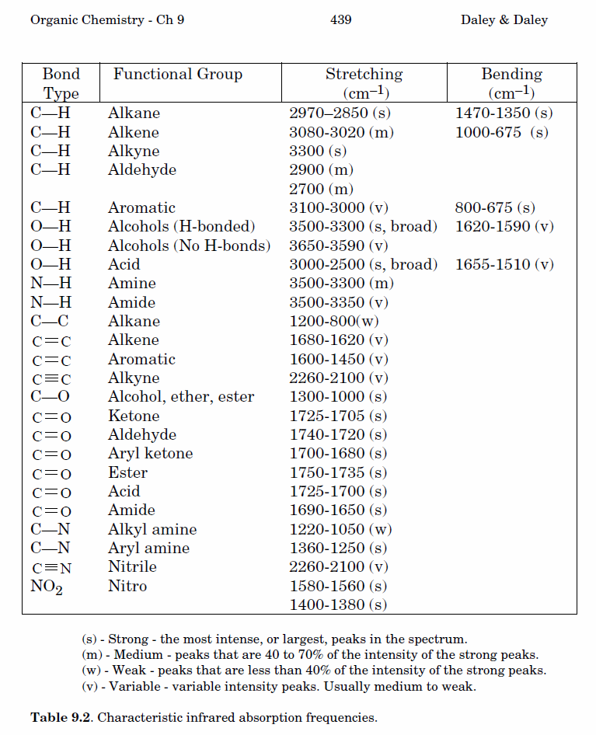9.-12. Classify each pair of numbered hydrogens on *cis*-1,4-dimethylcyclohexane to a topicity relation to the right. Answers may be repeated. For clarity, not all hydrogens are shown.

1. H1 and H2 a. constitutional heterotopic
2. H1 and H3 b. diastereotopic
3. H2 and H4 c. enantiotopic
4. H2 and H5 d. equivalent (homotopic) e. not a.-d.

13.-17. How many carbon signals do the following compounds have? Answer may be repeated.

1.  14.  15.  16.  17. 

a. 2 b. 3 c. 4 d. 5 e. not a.-d.

18.-22. Exactly match each 1H NMR spectrum to a compound below. Not all multiplicities are labeled.

1.  19.  20.  21.  22. 

a. 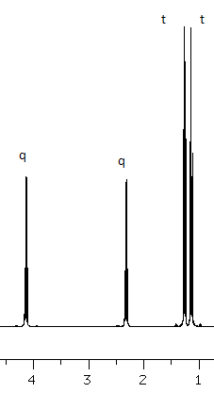b.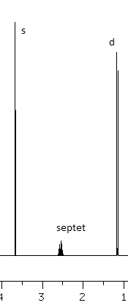c. 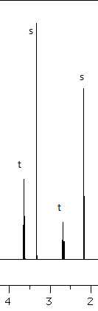 d. 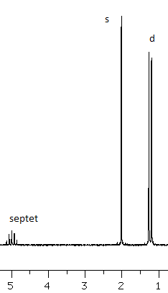e. 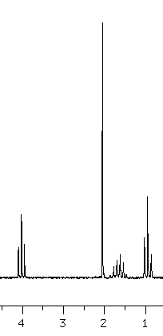

23.-27. Exactly match each IR spectral listings to a compound to the right. An IR table is on the back of the first sheet.

23.  24.  25.  26.  27. 

a.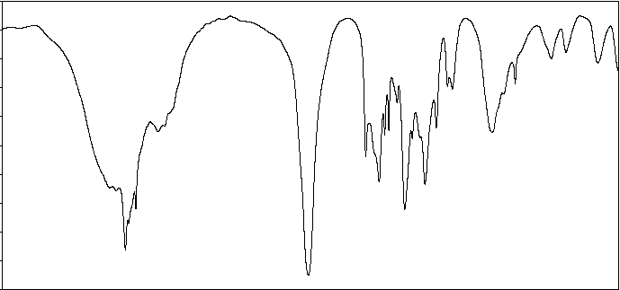

b.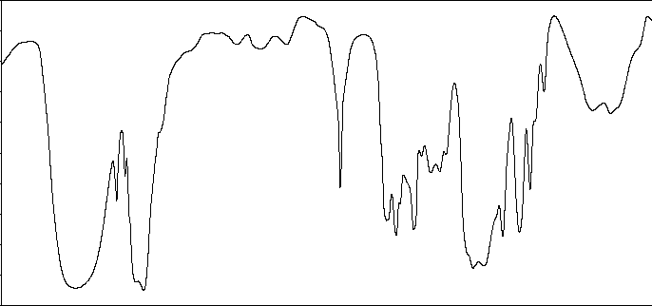

c.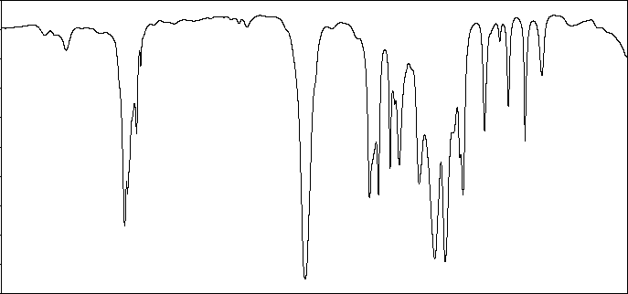

d.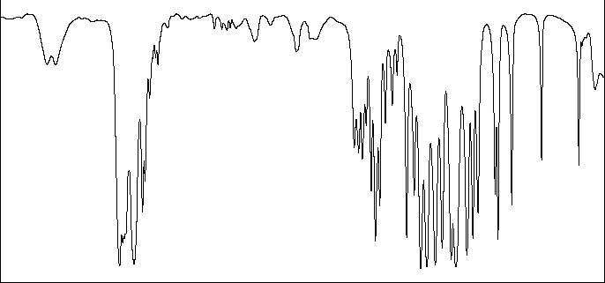

e.