CHEM 2324 Exam 4 ***Version A*** Name:

May 16, 2019 UTEP ID #:

The Exam 4 retake homework is due ***tomorrow***, Friday, May 17, before 5 pm through <http://organic.utep.edu/quiz>, no exceptions or excuses. Expect an email from me this evening.

1. How many *R* chiral centers does the following cat “attractant” have? 

a. 1 b. 2 c. 3 d. 4 e. not a.-d.

1. Is the structure in the following Newman projection? 

a. achiral but not meso b. chiral c. meso d. not a.-c.

1. What is the relation between the structure in question 2 and the following Fischer projection? 

a. constitutional isomers b. diastereomers c. enantiomers d. equivalents e. not a.-d.

1. For sure the enantiomer of the structure in question 3 is?

a. *l* b. *L* c. *d* d. *D* e. not a.-d.

1. What is the percent composition of the major enantiomer of a mixture of enantiomers that has an optical rotation of 50° when pure enantiomers of the same compounds have a specific rotation of ± 100°?

a. 50 % b. 60 % c. 67 % d. 75 % e. not a.-d.

1. How many enantiomer pairs are in the family of stereoisomers of the following core structure of a common “natural” sweetener? Don’t worry if some of the stereoisomers are not physically possible.



a. 128 b. 64 c. 32 d. 16 e. not a.-d.

1. The following 1,2-dimethylcyclohexane structures should have the same 13C NMR? 

a. true b. false

1. The following 1,2-dimethylcyclohexane structures should have the same biological activity? 

a. true b. false

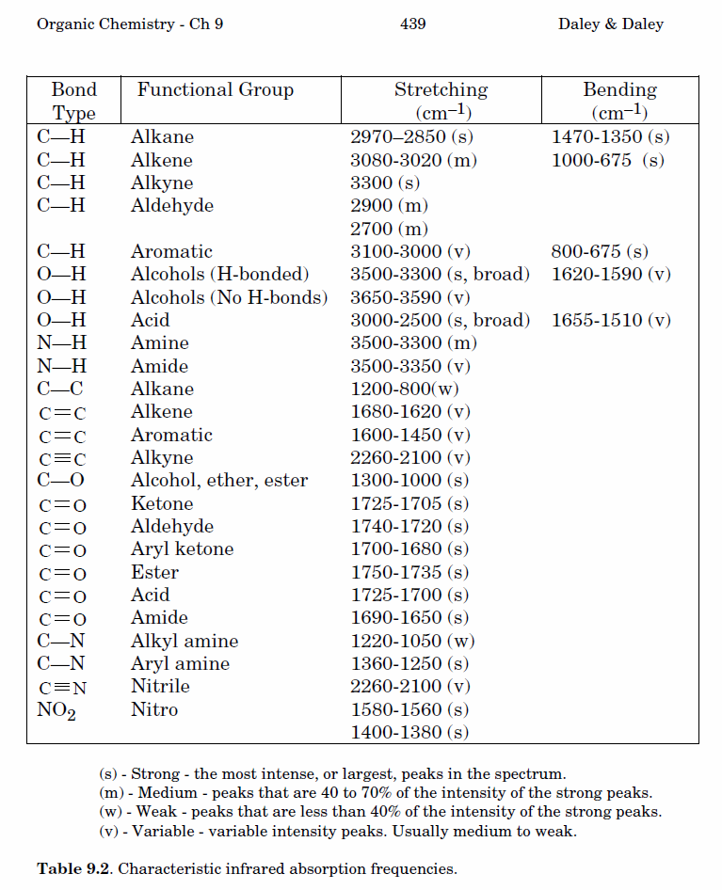9.-12. Classify each pair of numbered hydrogens on *trans*-1,4-dimethylcyclohexane to a topicity relation to the right. Answers may be repeated. For clarity, not all hydrogens are shown.

1. H1 and H2 a. constitutional heterotopic
2. H1 and H3 b. diastereotopic
3. H1 and H4 c. enantiotopic
4. H1 and H5 d. equivalent (homotopic) e. not a.-d.

13.-17. How many carbon signals do the following compounds have? Answer may be repeated.

1.  14.  15.  16.  17. 

a. 2 b. 3 c. 4 d. 5 e. not a.-d.

18.-22. Exactly match each 1H NMR spectrum to a compound below. Remember that coupling is not observed between equivalent or enantiotopic hydrogens because they are being observed at the same time. Integrations are not necessary to match these compounds.

1.  19.  20.  21.  22. 

a. 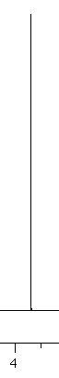 b. 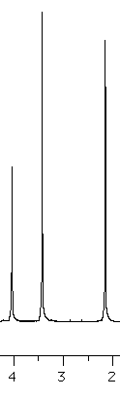 c. 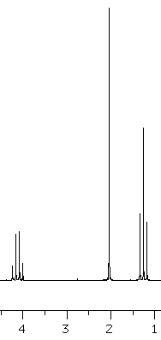 d. 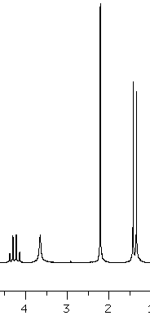 e. 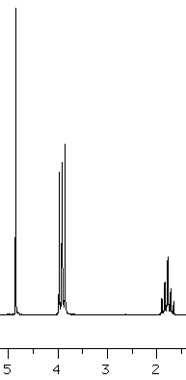

23.-27. Exactly match each IR spectral listings in cm-1 to a compound to the right. An IR table is given on the back of the first sheet.

1. 3311 (s), 2962 (s), 2120 (v) a. 
2. 3366 (s broad), 2974 (s) b. 
3. 2981 (s), 1718 (s) c. 
4. 2979 (s broad), 1707 (s) d. 
5. 2974 (s), 2260 (v) e. 

***Do not forget to put your name, ID, and version letter (A or B) on your scantron. Show a picture ID as you turn in your scantron.***