CHEM 2321 Exam 4 Name:

December 14, 2023 UTEP ID #:

The Exam 4 retake homework is due ***tomorrow***, Friday, December 15, before 5 pm through <http://organic.utep.edu/quiz>, no exceptions or excuses. Expect an email from me.

1. How many *R* chiral centers does the following chiral aziridine have? 

a. 1 b. 2 c. 3 d. 4 e. not a.-d.

1. Is the structure in the following Newman projection? 

a. meso b. chiral c. achiral but not meso d. not a.-c.

1. What is the relation between the structure in ***question 2*** and the following Fischer projection? 

a. constitutional isomers b. diastereomers c. enantiomers d. equivalents e. not a.-d.

1. If the compound in ***question 1*** is (*+*), for sure its enantiomer is?

a. *l* b. *L* c. *d* d. *D* e. not a.-d.

1. Given a 7:1 mixture of enantiomers has an observed specific rotation of 33°, what would be the specific rotation of the pure (*+*)-enantiomer?

a. 22° b. 44° c. 66° d. 88° e. not a.-d.

1. Considering that the following structure can be either *cis* or *trans* on the ring, how many stereoisomers are in the family of the following potential endocrine disruptor (compounds that mimics hormones)?

a. 4 b. 8 c. 16 d. 32 e. not a.-d.

1. The following has the same boiling point as the compound in ***question 3***? 

a. true b. false

1. The following smell the same?

a. true b. false

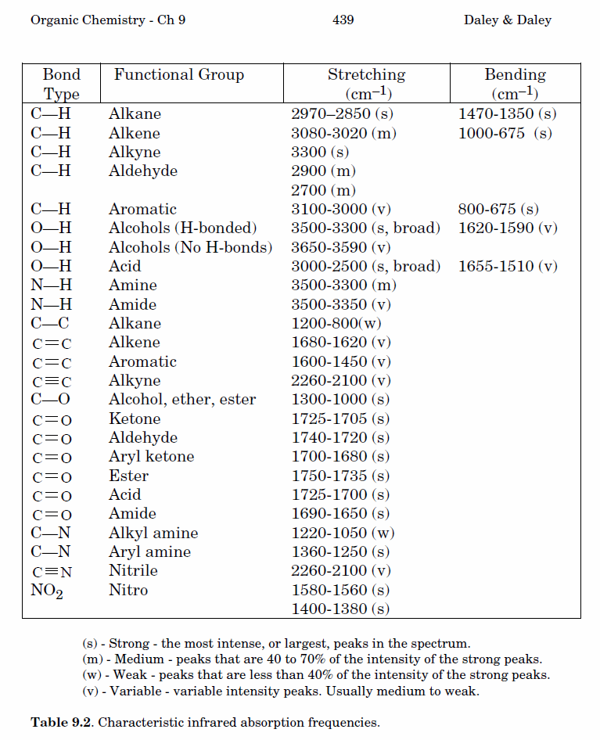

9.-12. Classify each pair of numbered hydrogens by a topicity relation. Answers may be repeated.

1. H1 and H11 a. constitutional heterotopic
2. H4 and H5 b. diastereotopic
3. H6 and H7 c. enantiotopic
4. H3 and H11 d. equivalent (homotopic) e. not a.-d.

13.-17. How many carbon signals do the following compounds have? Answer may be repeated.

1.  14.  15.  16.  17. 

a. 2 b. 3 c. 4 d. 5 e. not a.-d.

18.-22. Exactly match each compound to a 1H NMR spectrum below. For clarity, to the left of each spectrum is the splitting observed for the left most peak. 7 means a septet.

1.  19.  20.  21.  22. 

23.-27. Exactly match each compound to an IR in cm-1. An IR table is on the back of the first sheet.

23.  24.  25.  26.  27. 

1. A black and white image of a stream

   Description automatically generated
2. A black and white image of a stream

   Description automatically generated
3. A black and white image of a icicles

   Description automatically generated
4. A black line on a white background

   Description automatically generated
5. A black and white image of a stream

   Description automatically generated

